Add Catalog in different categories:
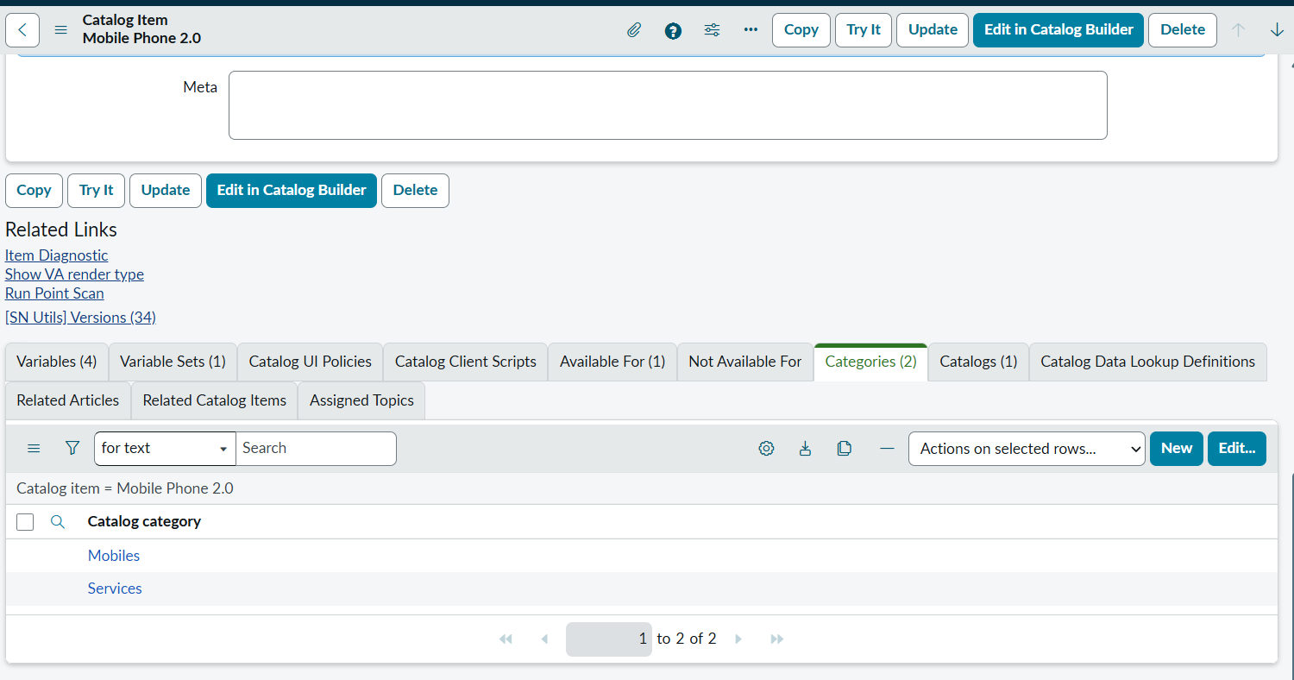
Categories are like :
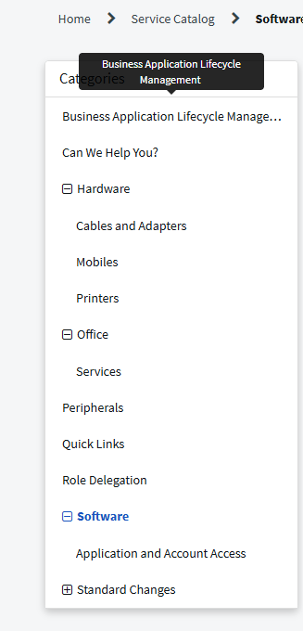
All sections are categories , if we click software also it show the added item, and if we click cables and Adaptes under that also it will show/

How can we make this + - signs before categories and hierarchy ?

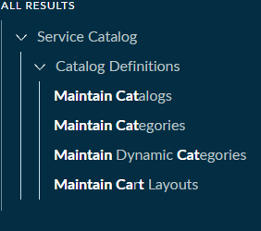
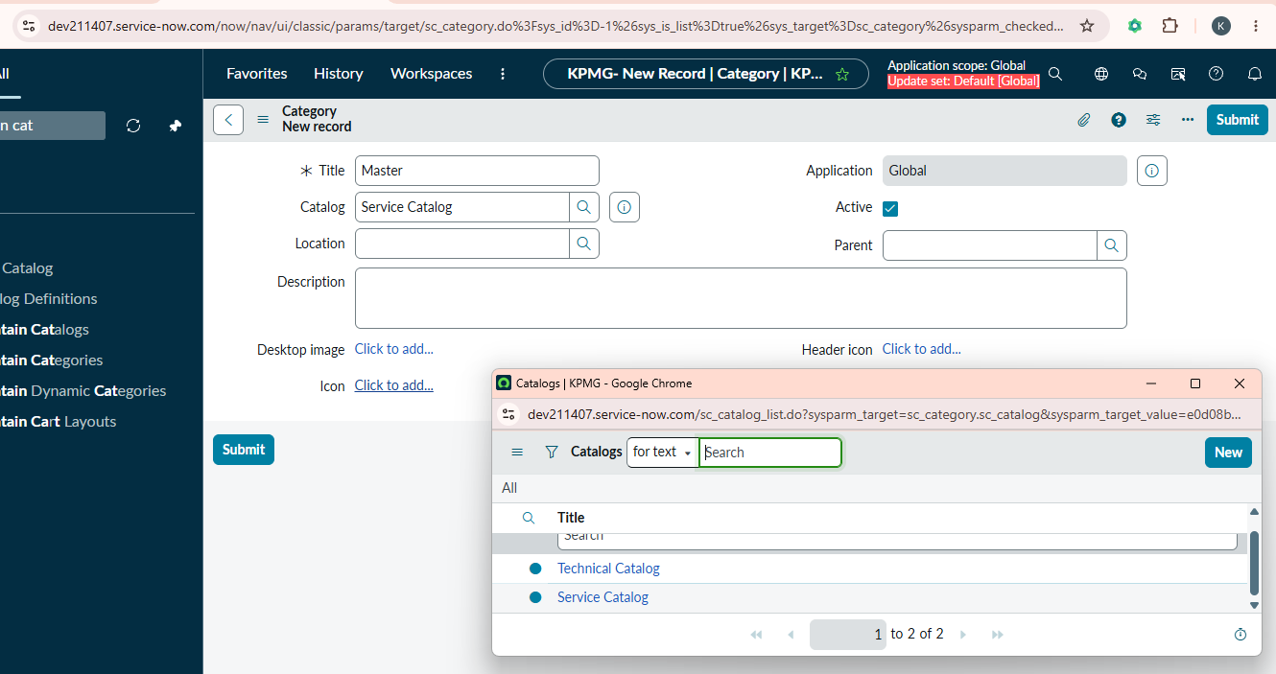

Leave the parent blank to make it a parent hierarchy so that it will show in service portal
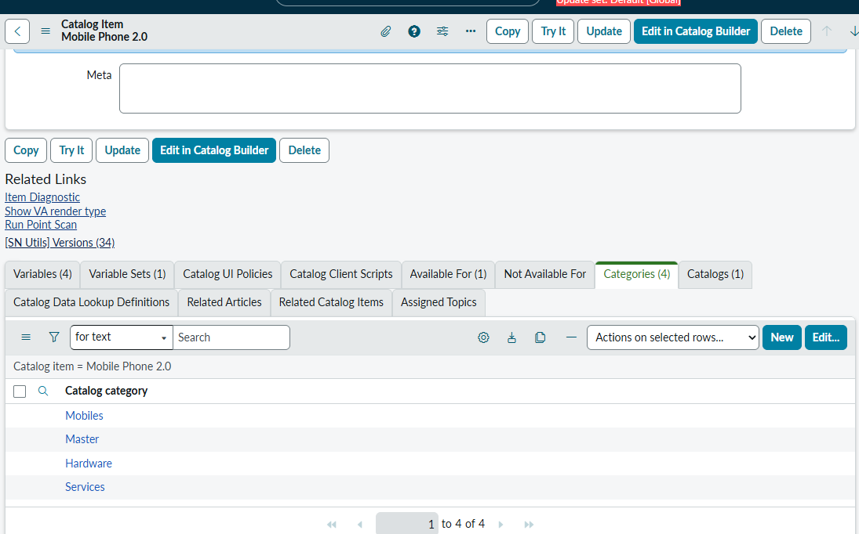
Now add categories for item –
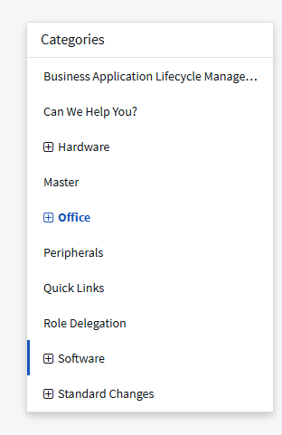

Go to categories Mobiles and change it parent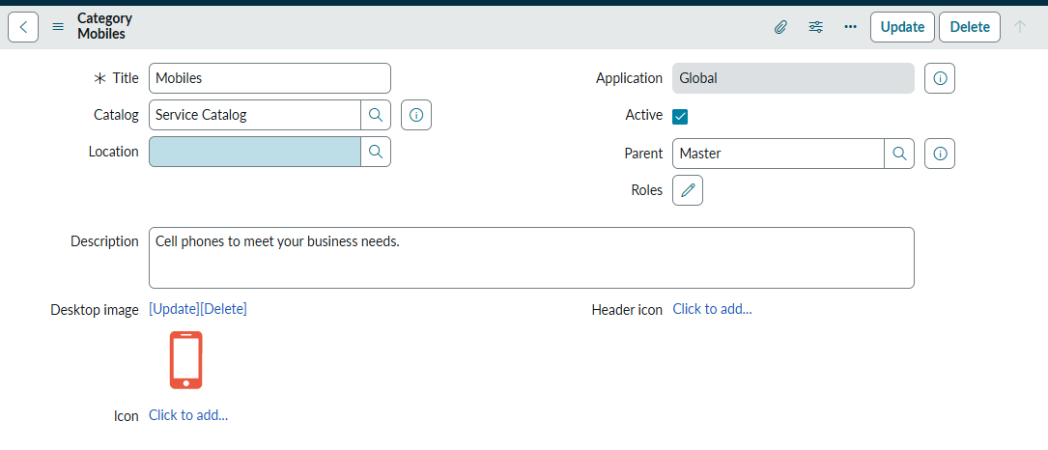
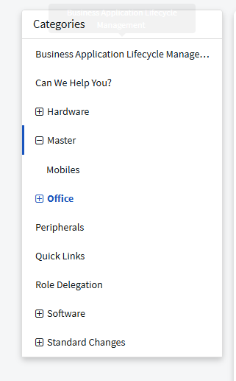

By default we will able to see service catalog in service portal only

If we want to add technical catalog as well we can go to portals
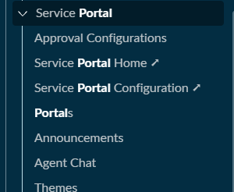

Maintain item <- maintain categories <- maintain catalog <- portals

Next topic we have : DATA LOOKUP DEFINITIONS
